**CS359 - Computer Network Lab**

**Lab 7**

Tarusi Mittal 1901CS65

1. CRC:

Compilation: g++ crc.cpp -o crc

Run: ./crc

Output:

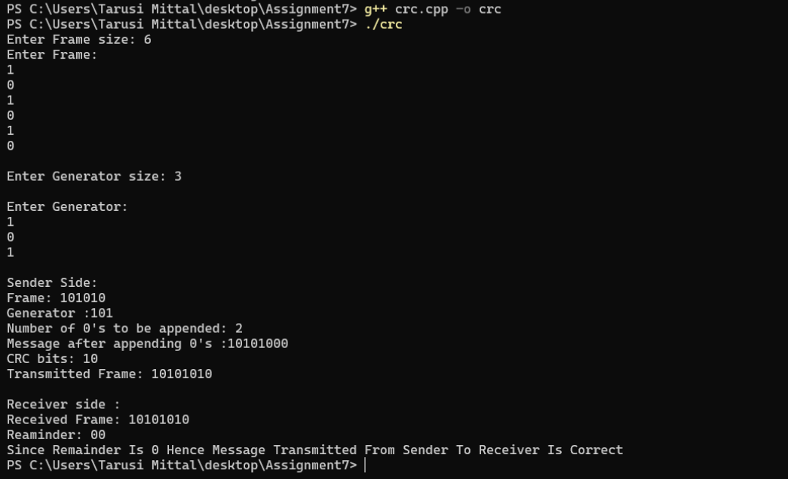

2. Hamming:

Compilation: g++ hamming.cpp -o hamming

Run: ./hamming

Output:

